# MEMORY CARD GAME REPORT

### A MINI PROJECT REPORT

#### Submitted by

#### Group/Team No: G-20/T14

**Aryan Semwal, 2310991796,**

**Aryan Yadav, 2310991797,**

**Ashpreet Singh Atwal, 2310991799**

#### in partial fulfillment for the award of the degree of

## BACHELEOR OF ENGINEERING

***in***

COMPUTER SCIENCE & ENGINEERING



**CHITKARA UNIVERSITY**

**CHANDIGARH-PATIALA NATIONAL HIGHWAY**

**RAJPURA (PATIALA) PUNJAB-140401 (INDIA)**

##### October & 2023

##### **Abstract**

Memory card games, a classic genre of entertainment and cognitive exercise, have retained their enduring popularity in the digital age. These games, rooted in the concept of uncovering matching pairs, offer a fascinating blend of mental acumen, entertainment, and the joy of competition. This abstract explores the essence of memory card games, their historical significance, cognitive benefits, adaptability, and the evolving digital landscape. The history of memory card games traces its roots to ancient China during the Ming Dynasty. Over time, this concept evolved and transcended cultural boundaries, becoming a universal pastime. In the late 19th and early 20th centuries, memory card games found their way into commercial production, captivating the hearts and minds of players worldwide. At the core of memory card games lies the art of memory enhancement. By challenging players to remember the positions of concealed cards and match pairs, these games promote the development of short-term and long-term memory skills. This exercise is accompanied by a host of cognitive benefits, including enhanced concentration, attention span, and problem-solving abilities. As a result, memory card games have become more than just recreational activities; they serve as tools for cognitive development and educational endeavours. The adaptability of memory card games is another hallmark feature. With a diverse array of themes, ranging from animals and history to popular characters, these games cater to a broad spectrum of interests and age groups. Furthermore, the digital era has ushered in a new dimension of accessibility, offering memory card games in the form of smartphone apps, online platforms, and video game adaptations. In conclusion, memory card games represent a delightful fusion of tradition and innovation. They harness the power of memory, enabling players to sharpen their cognitive abilities while revelling in enjoyable pastimes. As technology continues to reshape the landscape of gaming, memory card games remain a steadfast companion for individuals seeking both intellectual stimulation and relaxation. Whether in their traditional physical form or as interactive digital applications, memory card games continue to captivate and challenge, proving that the pursuit of memory is a timeless, fascinating journey.

###### **TABLE OF CONTENTS**

|  |  |  |
| --- | --- | --- |
| Sr No. | Section | Page No. |
| 1. | Introduction | 4 |
| 2. | Objectives | 5 |
| 3. | Scope | 5 |
| 4. | Problem Statement | 6 |
| 5. | Technical Details | 6 |
| 6. | Key Features | 7 |
| 7. | Advantages | 8 |
| 8. | Result | 9-12 |
| 9. | Conclusion | 13 |
| 10. | Future Scope | 13 |

**Project Title: Memory Card Game**

**Introduction**

Memory card games have long been a popular and engaging activity that serves a dual purpose—entertainment and cognitive exercise. These games have a rich history and offer numerous benefits, making them a significant part of leisure activities for people of all ages. Memory card games, often known as "concentration" or "matching" games, have a history that dates back centuries. The concept of matching pairs in a card game has been traced to ancient China, where a variant called "shoushiling" was played during the Ming Dynasty. Over time, this concept evolved and found its way into various cultures and societies. In the late 19th and early 20th centuries, card manufacturers began producing memory card games as a commercial product. In a world filled with digital distractions and information overload, the timeless allure of a simple yet captivating game remains unwavering. Welcome to the enchanting realm of memory card games, where the age-old challenge of matching pairs finds a delightful home. As you embark on this gaming journey, you'll discover that beneath its seemingly straightforward exterior lies a realm of mental dexterity, entertainment, and boundless fun. Memory card games have been cherished across generations for their unique ability to challenge and stimulate the human mind. At their heart, these games are a celebration of memory - that remarkable faculty that stores life's treasured moments, important details, and cherished faces. They beckon players to test their mental mettle, improving their ability to recall and retain information with every turn of a card. The rules are refreshingly simple: a grid of cards, each concealing a hidden image, waits to be explored. Your task is to reveal these images, two at a time, in search of matching pairs. But don't be fooled by the apparent ease of the game; as the grid expands, your memory will be put to the test. With each flip, you'll need to remember the locations of cards, harness your powers of observation, and develop winning strategies. The charm of memory card games lies in their adaptability and universal appeal. Whether you're a child discovering the joys of learning through play or an adult seeking a moment of relaxation and mental stimulation, these games transcend age and background. They come in an array of themes and variations, making them accessible to diverse interests, from the animal enthusiast to the history buff, and beyond. In this world of memory card games, players experience an amalgamation of concentration, cognitive development, and the joy of a friendly challenge. So, take a moment, sharpen your mind, and lose yourself in the enchanting world of memory card games, where every match you make is a victory over forgetfulness and a testament to the marvel of your memory.

**Objectives**

Develop a memory card matching game where players need to find matching pairs. The primary goal of this game is to enhance and challenge one's memory and concentration skills. Players are presented with a grid of face-down cards, and the objective is to find matching pairs of cards by flipping them over two at a time. This task requires players to remember the locations of previously revealed cards, as well as to develop strategies for uncovering pairs efficiently. The game aims to improve memory recall, attention to detail, and cognitive agility. Additionally, it provides a fun and interactive way to stimulate the brain, making it a popular choice for educational and recreational purposes.

**Scope**

1. Target Audience: Identify the specific age group or demographic you want to target with your memory card game. Will it be designed for children, adults, or a broader audience.
2. Gameplay Complexity: Determine the level of complexity you want to offer in your game. Will it be a straightforward matching game, or will it incorporate additional gameplay elements like different levels.
3. Platform and Technology: If you're developing a digital game, specify the platforms and technologies you plan to use. Are you building a web-based game, a mobile app, or a desktop application.
4. Art and Design: Determine the visual style and design of your game, including the graphics, card layouts, and user interface.
5. Scalability: Consider whether the game can be expanded with additional levels, challenges, or content to keep players engaged over time.
6. Testing and Feedback: Plan for playtesting and gathering user feedback to refine and improve the game based on user experiences.
7. Legal and Copyright Considerations: Ensure that you have the necessary licenses or permissions for any copyrighted material or intellectual property used in the game.
8. Marketing and Distribution: Define how you plan to market and distribute your game. Will it be available on app stores, websites, or physical stores? Consider marketing and promotional strategies.

**Problem Statement**

In today's fast-paced and digital world, individuals of all ages often face challenges related to memory retention, concentration, and cognitive function. These challenges can affect academic performance, job productivity, and overall quality of life. While numerous cognitive enhancement programs and memory-boosting techniques exist, many individuals find these methods uninteresting and challenging to maintain. Therefore, there is a need for an enjoyable and effective solution to improve memory and cognitive skills.

**Technical Details**

We have used the following technologies for making this project: -

1. HTML- It stands for Hypertext Markup Language, is the fundamental technology that powers the structure and content of web pages, serves as the backbone of the World Wide Web.
2. CSS- It is known as CSS, is a crucial technology in web development that complements HTML. CSS empowers web designers and developers to control the visual presentation and layout of web content.
3. VISUAL STUDIO CODE- The software used to write the code is vs code it has been extremely useful to write, edit and compile our codes together as a team. Project Structure:

The Source Code of the file consists of 5 HTML files named “frontpage.html”, “level.html”, “index.html”, “index1.html”, “index2.html” and one 5 CSS files named “style0.css”, “style3.css”, “style.css”, “style1.css”, “style2.css”.

**Key Features**

1. Clear and Easy to Access Navigation: The webpage includes a clear and user-friendly navigation menu that allows visitors to easily explore different sections of the game.
2. Grid of Face-Down Cards: The game starts with a grid of face-down cards arranged in rows and columns. Players must flip these cards over to reveal the images or patterns on the other side.
3. Memory Challenge: The core challenge of a memory card game is to remember the locations of the cards and match pairs by flipping over two cards at a time. If the cards do not match, they are turned face-down again.
4. Difficulty Levels: Memory card games often feature different difficulty levels. These levels can vary the size of the grid, or the number of card pairs. The player can itself select the level of difficulty according to his capability.
5. Themes and Variations: Memory card games can come in various themes and variations. These themes might include animals, numbers, letters, shapes, or popular characters. The choice of themes can make the game more engaging for specific audiences.
6. Free of cost and Ad-Free: As nowadays all games contain ads and to remove that you have to take premium. This game is ad free and you can play it for free.
7. High-Quality Images: High-resolution images sourced from “https://drive.google.com/file/d/1LABG8fzaDYzD_p_PGlz1OWJTeR3UjG58/view” are used to visually showcase the game, ensuring a visually appealing presentation.

**Project Advantages**

1. Memory Enhancement: As the name suggests, memory card games are excellent tools for enhancing memory skills. They require players to remember the locations of cards, which exercises both short-term and long-term memory.
2. Cognitive Development: These games promote cognitive development by improving skills such as pattern recognition, spatial memory, and logical reasoning. Players learn to make connections and use strategies to find matching pairs.
3. Concentration and Focus: Playing memory card games demands sustained concentration and focus, as players need to pay close attention to the cards on the table to identify matching pairs. This helps improve attention span.
4. Problem-Solving Skills: Memory card games encourage problem-solving and critical thinking. Players develop strategies to efficiently match pairs of cards, which can be transferable to other real-life problem-solving scenarios.
5. Stress Reduction: Engaging in memory card games can be a relaxing and stress-reducing activity. The simplicity of the game and the immersion it provides can help individuals unwind and escape from daily stressors.
6. Entertainment and Fun: One of the primary advantages of memory card games is their entertainment value. They offer a fun and engaging pastime, making them suitable for people of all ages and backgrounds.
7. Accessibility: Memory card games are widely accessible. They can be played using physical cards, and they are also readily available as digital applications and online games, making them accessible to a broad audience.
8. Adaptability: These games are highly adaptable, allowing for different themes and variations to suit various interests and age groups. Whether it's a themed version based on animals, history, or popular characters, there is a memory card game for everyone.
9. Mindfulness and Relaxation: Some people use memory card games as a form of mindfulness exercise, where they immerse themselves in the game, which can be calming and meditative.

**Results**

* **Home Page:**

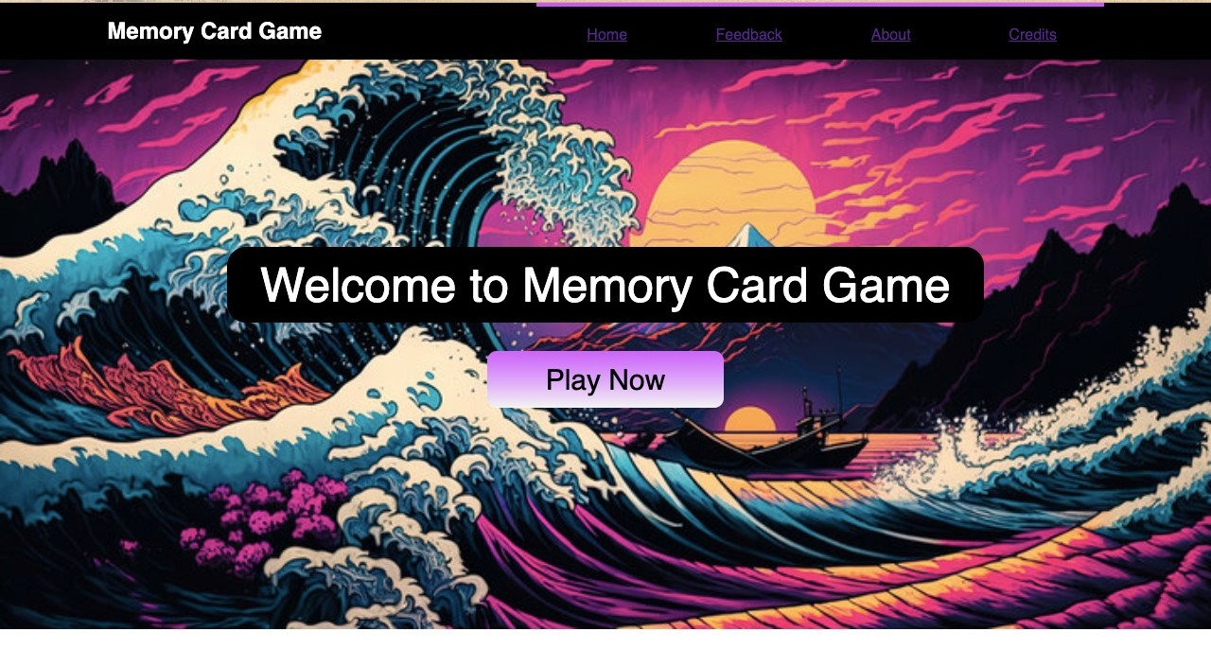

* **Level Selection Page:**



* **Easy Game Page:**

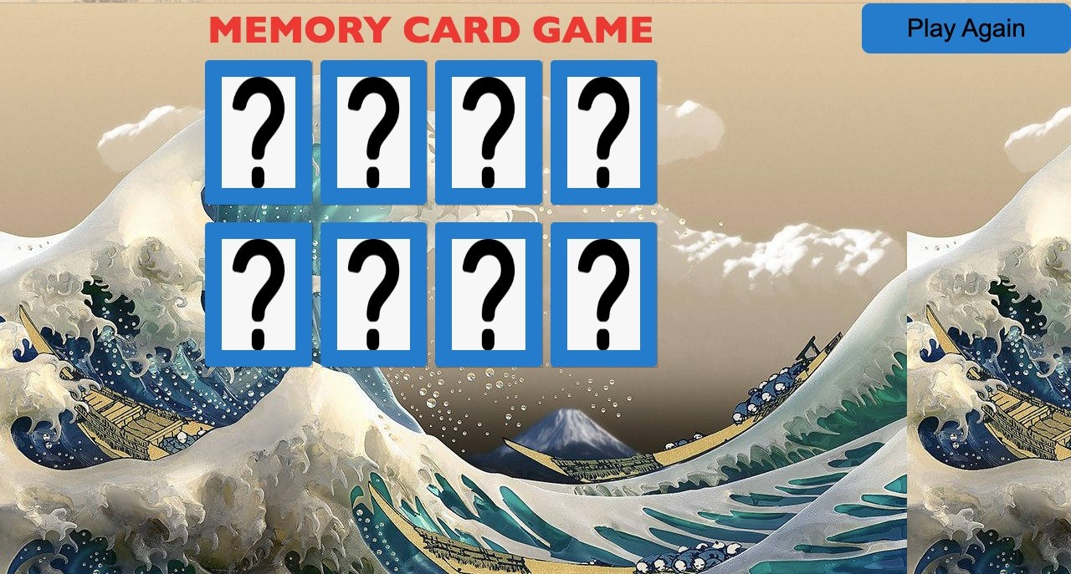

* **Medium Game Page:**

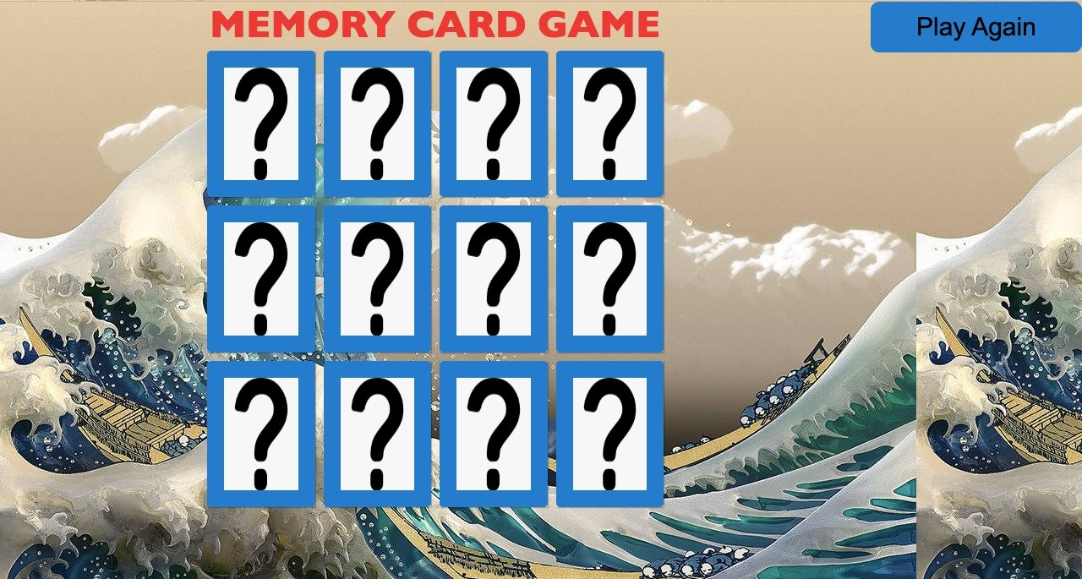

* **Hard Game Page:**

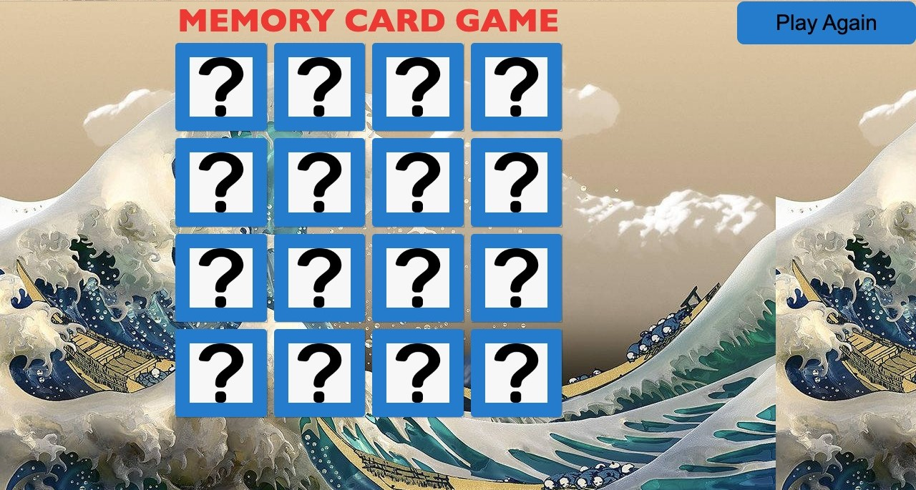

* **About Page:**

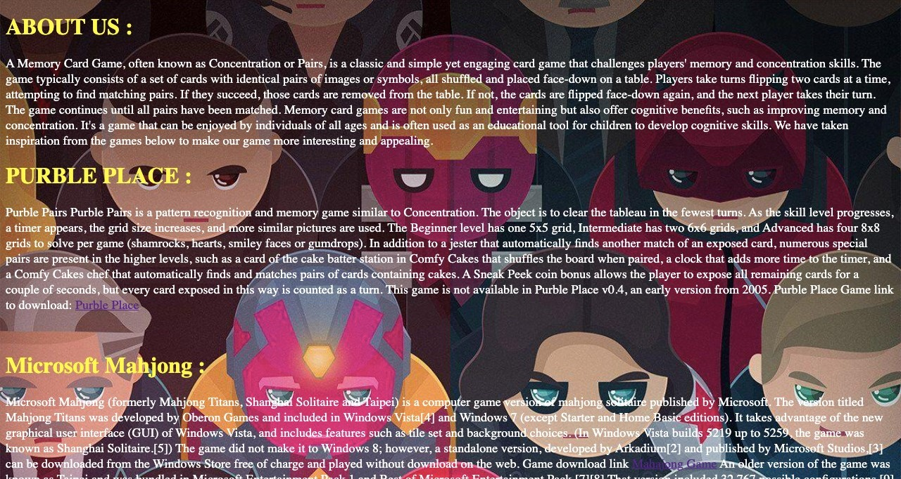

* **Feedback page:**



* **Credits Page:**



**Conclusion**

Memory card games are more than just a pastime; they are a valuable tool for memory enhancement, cognitive development, and entertainment. Their historical significance, benefits, adaptability, and widespread popularity make them a timeless and accessible option for individuals looking to sharpen their memory skills while having fun. Whether in traditional card form or as digital applications, memory card games continue to engage and educate people across the globe. The HTML and CSS-based product Memory Card Game successfully met project objectives, delivering a user-friendly, and visually appealing solution. The inclusion of bonus features further enhanced usability and engagement, positioning Memory Card Game for offline success.

**Future Scope**

* Enhanced interactivity through JavaScript.
* Turning of cards.
* Matching two same images and when all images matched end of game.